MALDEF files class action lawsuit against Southern California car washes
By Ruxandra Guidi | May 21, 2012

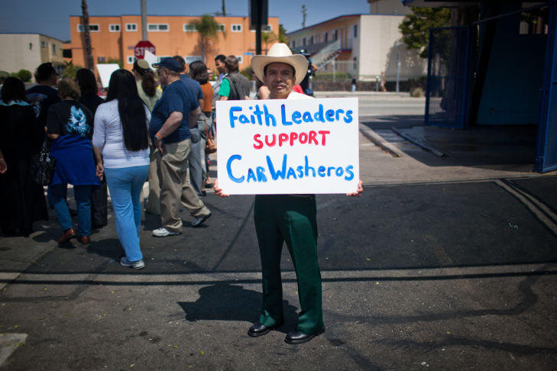
Grant Slater/KPCC

Jose Sanchez of Santa Monica joined a protest at Santa Monica Car Wash where union officials and community leaders rallied on Monday, May 21.

A civil rights organization has filed a class-action lawsuit against Southland car washes, this time alleging pay, health and safety violations.
The CLEAN Carwash Campaign, a coalition that works on behalf of low-wage earners, calls Southern California car washes the “new sweatshops.”
The group says car wash businesses that employ up to 100 manual laborers routinely hire Latino workers and violate their protections under the California Wage and Hour Law.
MALDEF (The Mexican American Legal Defense and Educational Fund) has filed a lawsuit in Los Angeles Superior Court against three car washes under the same management.
“These car washes, in order to make their business more profitable, aren’t paying the workers the wages that they’re entitled to," said Victor Viramontes, MALDEF's national senior counsel. "They’re not giving them overtime, they’re making them work off the clock, they’re shortcutting the pay across the board. That’s pretty much the way the industry has been set up, and that’s not acceptable.”
Viramontes said the class-action lawsuit seeks back wages for 100 workers it claims the owners deprived of required breaks, lunch time and overtime pay.
The suit also claims carwash owners forced the employees to clock out before they finished their shifts.
Under California law, immigration status is irrelevant to a worker’s ability to recover lost wages. The state attorney general’s lawsuit on other car wash workers’ behalf led to the first union car washes in the Southland last fall.
Management at the three car wash businesses in Santa Monica and Venice declined interview requests for this story.

